GRAPH

**Table of Contents**

INTRODUCTION 1

GRAPH PRESENTATION 4

TRAVERSAL 7

BFS TRAVERSAL 7

DFS TRAVERSAL 7

DIJKSTRAs ALGORITHM 8

MINIMUM SPANNING TREE 12

TYPES OF EDGES 12

# **INTRODUCTION**

G=(V,E)

**Vertex** – is a node. Vertices – is plural

**Edge** – is an element of graph

V- set of vertices (objects)

E- set of edges

**Order of graph** – is number of vertices (objects, elements)

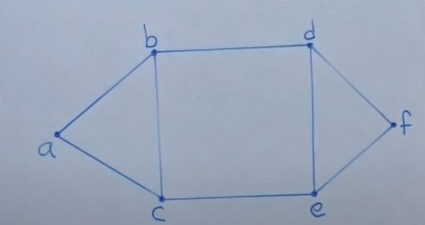

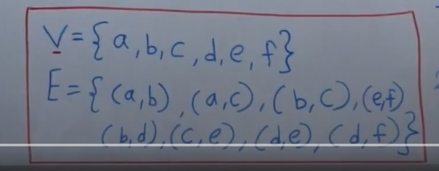

If consider an example of social network

(a,b), (a,c) -are friends, but (a,f) are not friends

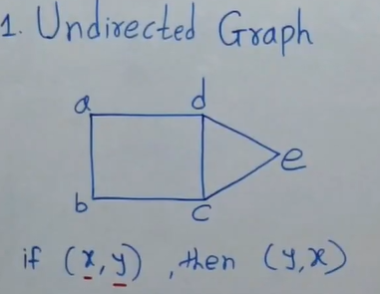

**Undirected graph** - if there is an edge between (a,b) => there is also an edge between (b,a). For example,

If [a] is a friend of [b], then [b] is also a friend of [a]

It is called **sibling relation**.

* (!) undirected graph always has a cycle, because you can simple go back and forth between any two neighbors
* Difference between trees and graphs that graphs do not have cycle

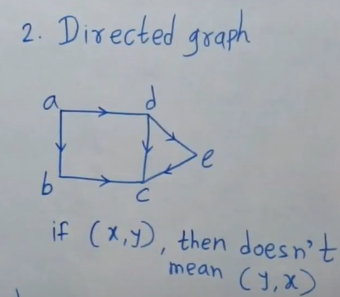

For example, it is like a follower relation. If [a] follows [b], it does not mean [b] is also a follower of [a]

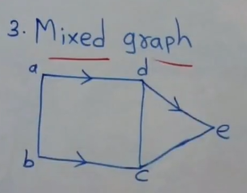

Example, of job scheduler

# **GRAPH PRESENTATION**

Graph can be present as:

* Adjacency matrix
* Adjacency list

**WEIGHTED GRAPH**

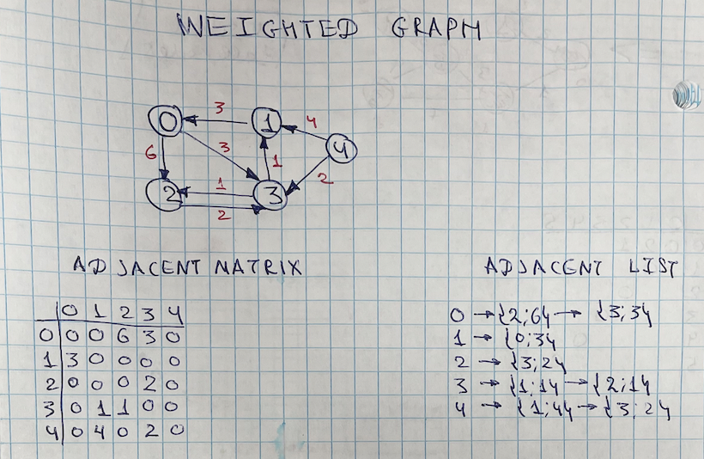

**UNWEIGHTED GRAPH**

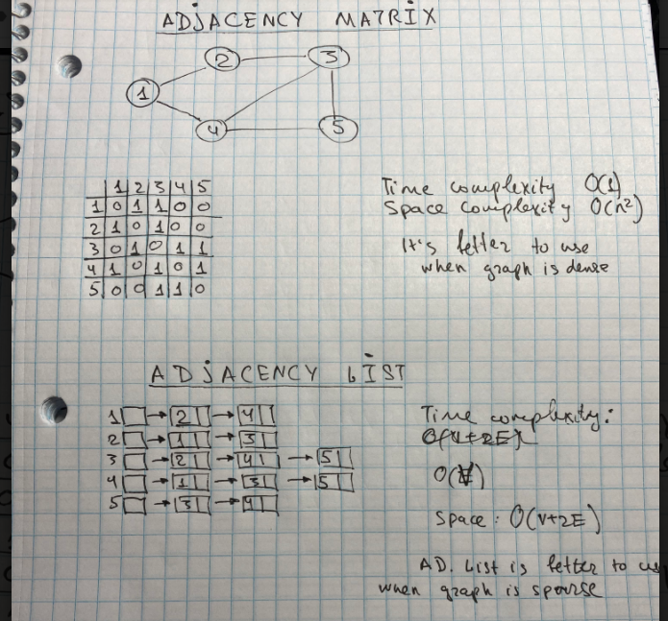

DFS vs BFS

* DFS and BFS is a way of searching. It’s not only for graph. It is a general term. It has a goal to search relations. It can be used to find a distance in a string.

**DFS** it is goes first deep and then goes back

Stack (LIFO) is used

**BFS** – goes wide

Queue (FIFO) is used

Steps:

* Pull a node
* Process if not seen and mark as seen when it is processed
* Add childers

# **TRAVERSAL**

When we talk about traversal, it’s not just about graphs. It’s about relations. Traversal can used for

* graph
* trees,
* string distance.

There are two types of traversal

* **BFS (Breadth First Search) –** is level order traversal. You use Queue for iterative implementation
* **DFS (Depth First Search)** -

## BFS TRAVERSAL

Idea:

1) choose any node as a root

2) data structure Queue. You will explore nodes

Facts:

* For iterative approach Queue is used
* Time complexity O(V+E)
* BFS is going layer by layer

## DFS TRAVERSAL

Idea:

1) choose any node as a root

2) data structure Queue. You will explore nodes

Facts:

* For iterative approach Stack is used
* Time complexity O(V+E)
* DFS is like preorder search for Binary Tree
* DFS is used when we want to find path, for a backtracking. DFS is about going deep

# **DIJKSTRAs ALGORITHM**

**Dijkstra algorithm** is the algorithm to find shortest path between two vertices

**script:**

https://github.com/oleksiisaiun/JAVA/blob/master/ALGORITHM/DATA-STRUCTURES/GRAPH/TRAVERSAL/SHORTEST_PATH/DIJKSTRA_ALGHORITHM/DIJKSTRA_ADJACENT_LIST/Dijkstra_algh_adjacent_list.java

**approach**

***1.preliminary steps***

1. choose a start Vertex. It can be any vertex
2. do preliminary step – for start vertex set up zero cost and for the rest of infinity (It can be, for example, Integer.MAX_VALUE)
3. create a data structure to track visited vertices ()for example, HashSet or array)
4. create min heap, where you will add adjacent vertices (compared to that node that you consider) and keep nodes sorted based on cost(each time you will [poll] vertex with minimum cost)

***2.logic of Dijkstra***

1. choose a start Vertex
2. push start Vertex into heap
3. poll vertex from heap
4. mark it as seen
5. explore adjacent vertices
6. for each adjacent vertex that has not been seen check cost based on condition

*if [scr.cost] + [cost on edge from src to dst] <[dst].cost*

*then*

*we setting up new cost for destination as {[scr.cost] + [cost on edge from src to dst]}*

*else no changes*

1. repeat steps u[3,4,5,6] until heap is not empty
2. push adjacent and not visited destination vertices into heap

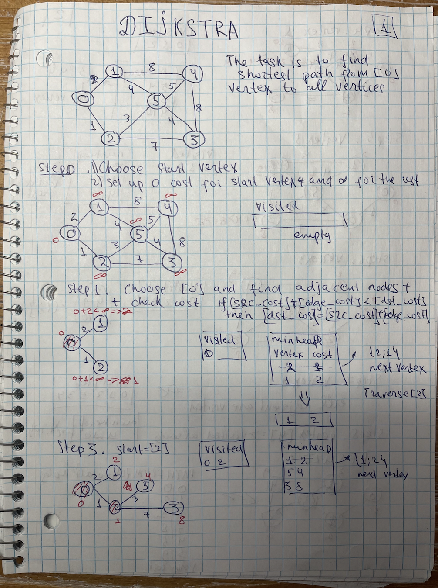

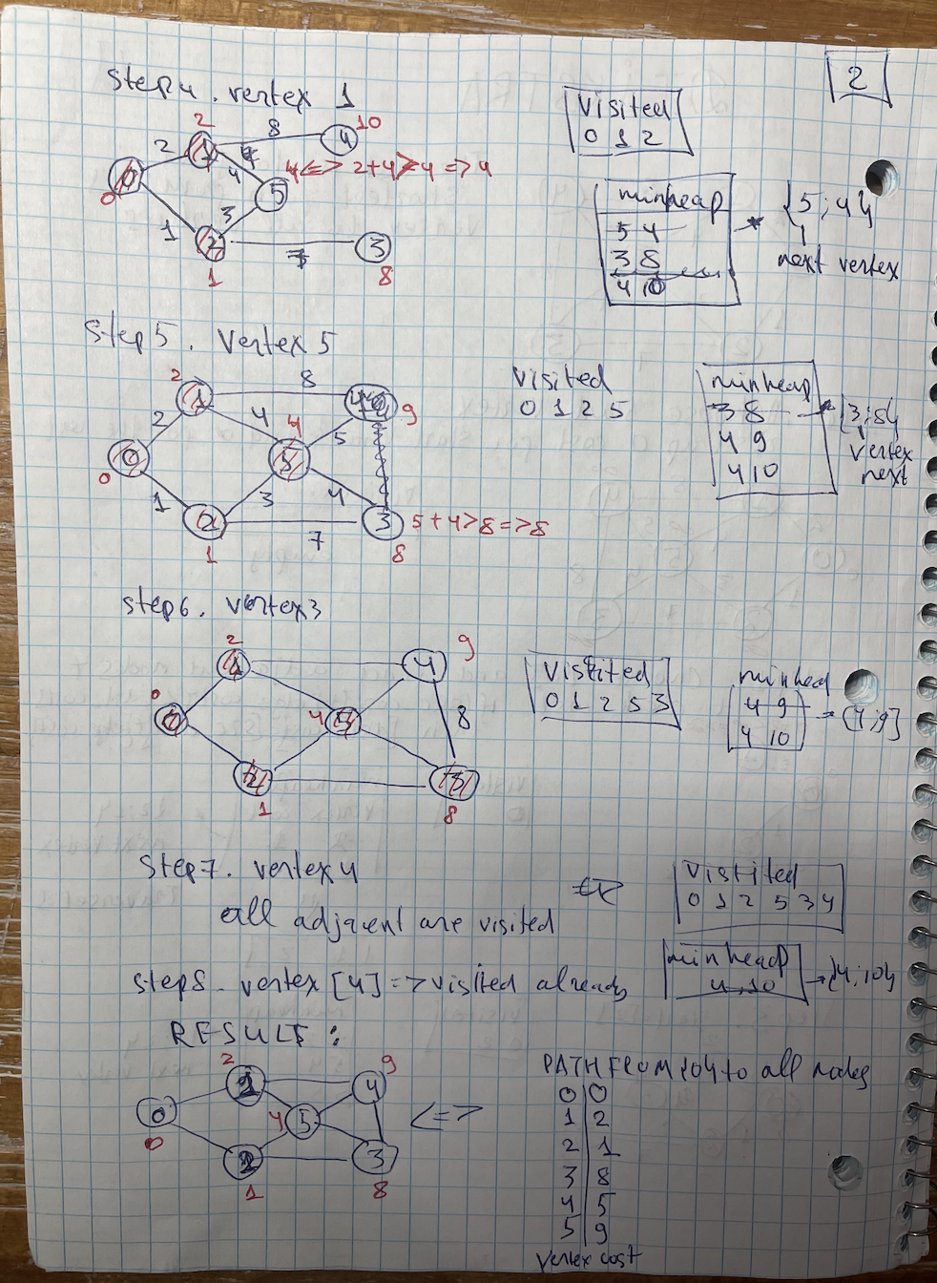

cons:

Dijkstra may work and may not work when cost is negative. It’s not always cost must be positive. There are cases when cost can be negative – for example, bank balance

# **MINIMUM SPANNING TREE**

**Minimum Spanning Tree (MST)** - is a subset of edges of a connected graph that connects all vertices together. Graph can have a few MSTs (with the same weight/cost)

## PRIM’s ALGORITHM

Prim’s algorithm is an algorithm to find MST

**code**

https://github.com/oleksiisaiun/JAVA/blob/master/ALGORITHM/DATA-STRUCTURES/GRAPH/TRAVERSAL/MINIMUM_SPANNING_TREE/PRIM_ALGHORITHM/MST_Prim_alghoritm.java

**approach**

***1.preliminary steps***

1. choose a start Vertex. It can be any vertex
2. create a data structure to track visited vertices (for example, HashSet or array)
3. create min heap, where you will add adjacent edges

***2.logic of Dijkstra***

1. choose a start Vertex
2. explore all adjacent vertices except already visited and add them into heap
3. poll an edge with min heap and mark it as visited
4. repeat #2 and #3 while heap is not empty

note: each time when you poll edge, you poll it among all adjacent vertices of visited vertices

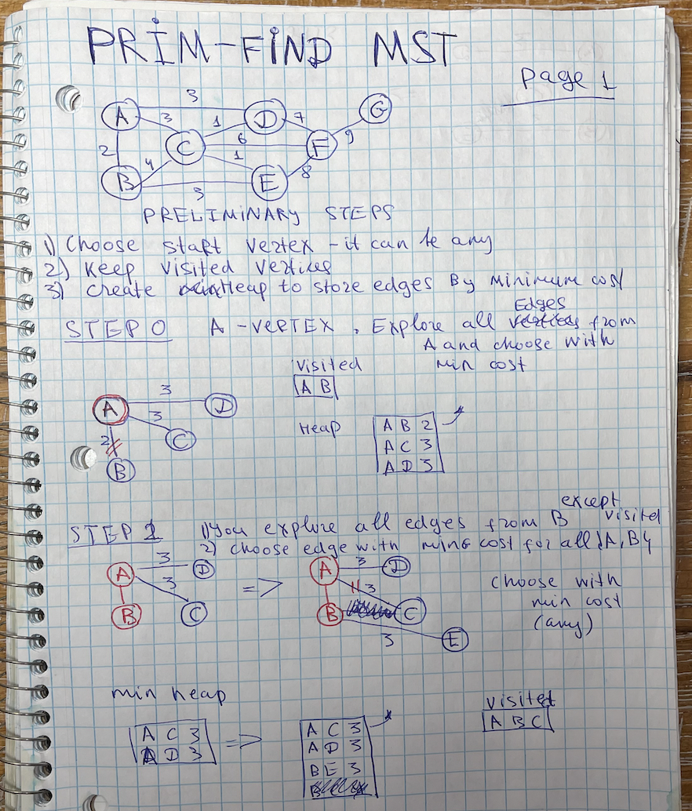

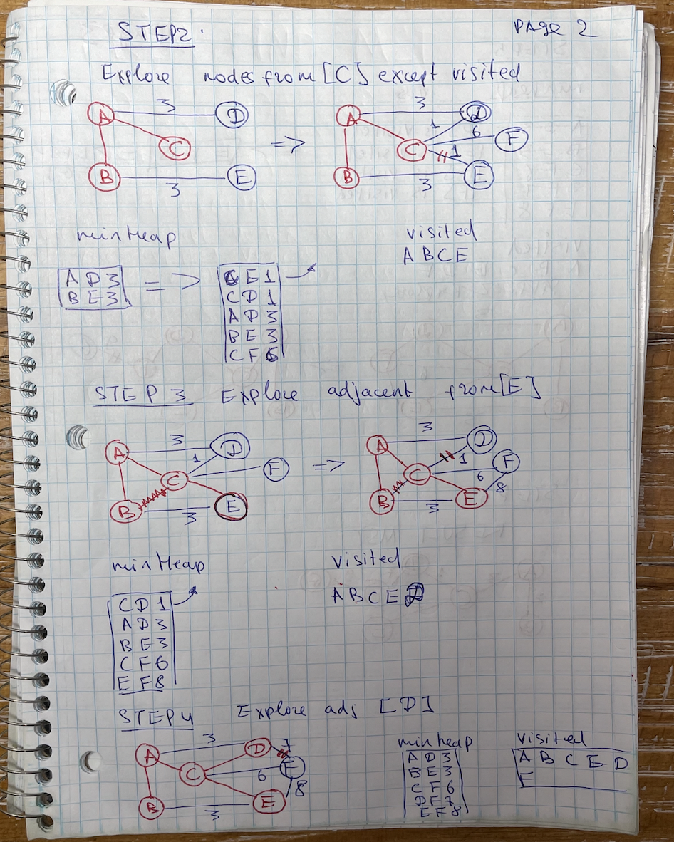

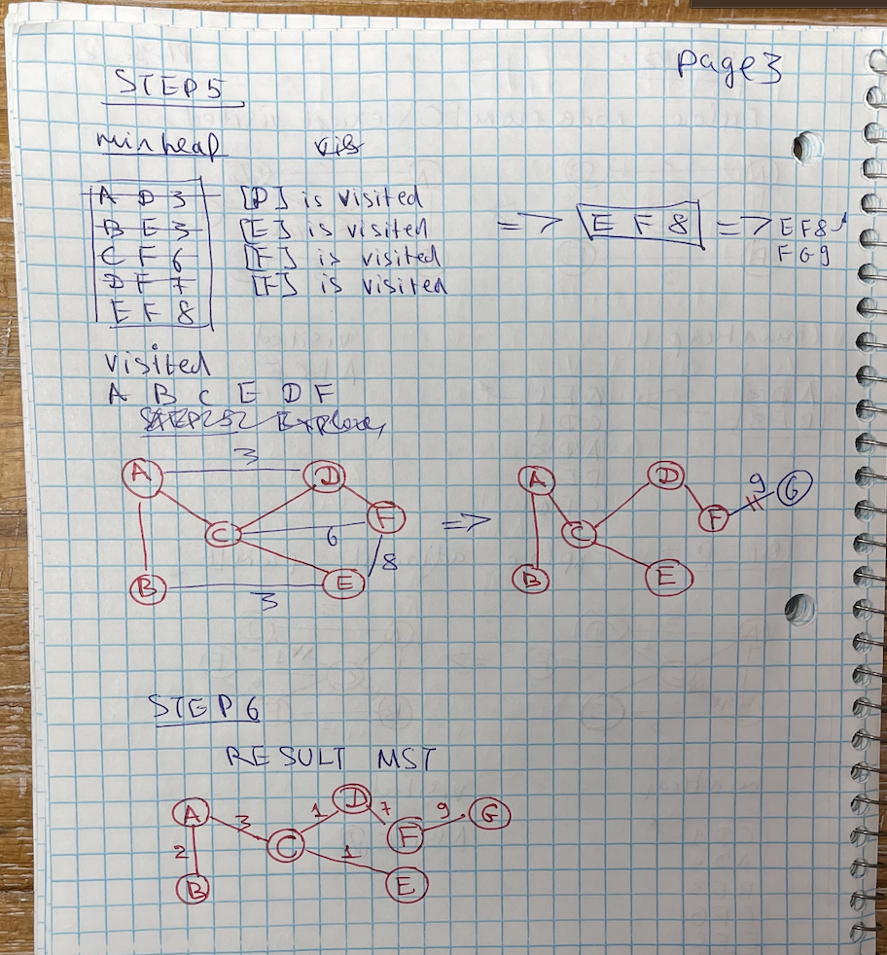

# **TYPES OF EDGES**

There are four types of edges in DFS traversal

Tree edge – member of DFS traversal

Forward edge – G(x,y) where [y] appears after [x] and there is a path between [x] and [y]

Back edge - G(y,x) where [y] appears before [x] and there is a path between [x] and [y]

Cross edge - G(y,x) any edge from [x] to [y], where there is no path from [y] to [x]

